Wood Buffalo National Park & Aurora College
Speakers Series
Invites you to meet a very special Canadian
Dr. Roberta Bondar
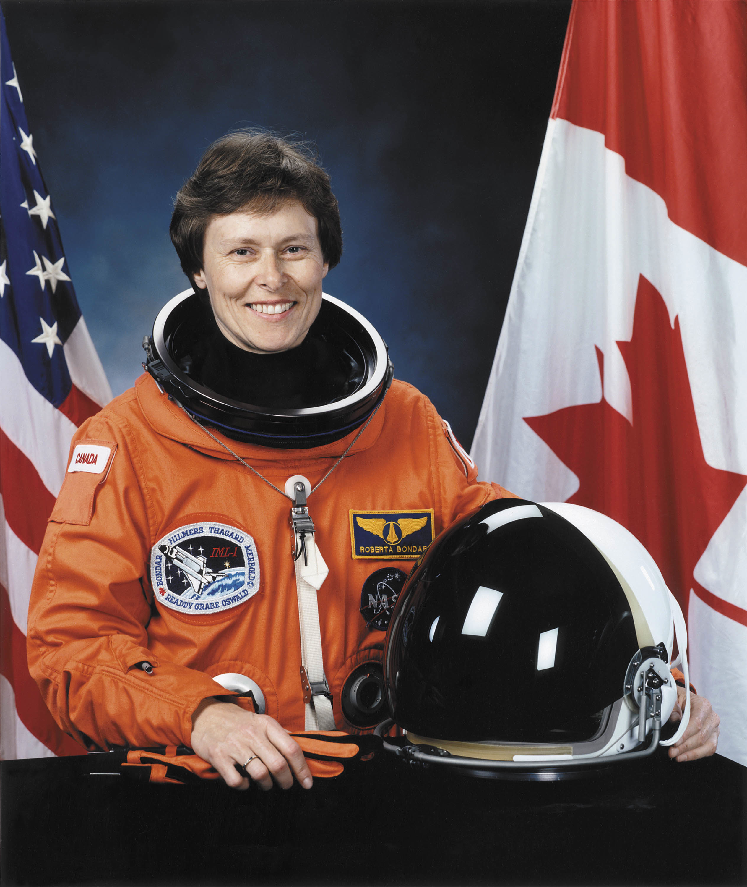
- Canada’s first woman astronaut, in January 1992 on the space shuttle Discovery.
- A noted Canadian photographer who has taken photographs in Wood Buffalo National Park on three separate occasions.
- A published author
- Holder of the NASA Space Medal
- Inducted into the International Women's Forum Hall of Fame & Canadian Medical Hall of Fame for her groundbreaking research in space medicine,
- Received 24 honorary doctorates from Canadian and American universities.
- A recognized “Wisdom Warrior” who shares her insights and experiences on the environment, innovation, discovery and leadership.

Where - Aurora College Room 148R
Date - Monday June 11, 2012
Time - 7:30 – 8:30 pm

Fun and interesting for all ages, this promises to be a special and memorable evening in Fort Smith.



